October 2024

To Area Meeting Clerks

Dear Friend,

Junior Yearly Meeting (JYM) 2025
This letter outlines information about JYM 2025 and how to complete the nominations task.

About the event JYM 2025 is a residential event for young people that takes place from Friday 23 – Monday 26 May. JYM is planned and facilitated by an Arrangements Committee of young people appointed by their peers. They work with the staff and volunteer team in the planning and facilitation of the event. Please do all you can to offer this opportunity to young people connected to your Quaker community.

We know that the date of JYM may fall during exams for many young people this year, so please encourage young people to check their exam dates and consider this carefully. JYM 2025 happens at the same time as Yearly Meeting, so we hope there will be opportunities for participants to join Yearly Meeting in session online, and in person on Monday 26 May.

To nominate young people Please read the nominations guidance and complete the form which can be accessed online at https://ycf.quaker.org.uk/jym-nomination-form/

Your AM should also minute who will progress the nomination. This person will need the following information to complete the nominations form:
- Email address, postal address and date of birth for each young person
- Phone number and email address for a parent/guardian for each young person
- Phone number and email address for person making payment (e.g. AM Treasurer)

The closing date for nominations is Sunday 9 February 2025. No places can be guaranteed for nominations received after this date.

If you are not nominating Please let us know so we can give your Area Meeting’s places to other young people. You can do this using the online form or by emailing cypadmin@quaker.org.uk

Who JYM is for: Each Area Meeting can nominate three young people for guaranteed places; you can also nominate additional places. Nominees should be born between
1 September 2006 and 31 August 2009, inclusive.

If you have young people in your meeting who fall below this age range, Young People @ Yearly Meeting will be taking place at the same venue for 11-15 year-olds.

JYM is an important opportunity for young people whether they are already involved in Quaker activities or are currently loosely connected to Quakers. Participating in JYM has the potential to be of enormous benefit to them and to Quakerism as a whole. For young Quakers, it can be a formative event for their Quaker identity.

Thank you for your part in the nominations process for JYM 2025.

In friendship
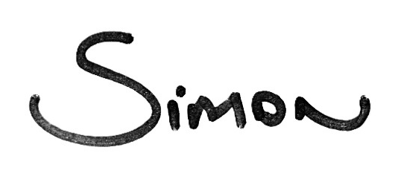 |  | 
Simon Hardie  Team Leader – Youth, Children and Families  simonh@quaker.org.uk  020 7663 1134 |  | Jenny Baines  Young People’s Administration and Project Officer  jennyb@quaker.org.uk  020 7663 1002

Information
All nominations documents can be found at https://www.quaker.org.uk/events/junior-yearly-meeting-2025

Nominations Guidance: Please use this to guide your nominations. You should give this to those responsible for JYM nominations in your Area Meeting.

A leaflet for young people: This is to give to all young people who might consider participating.

