  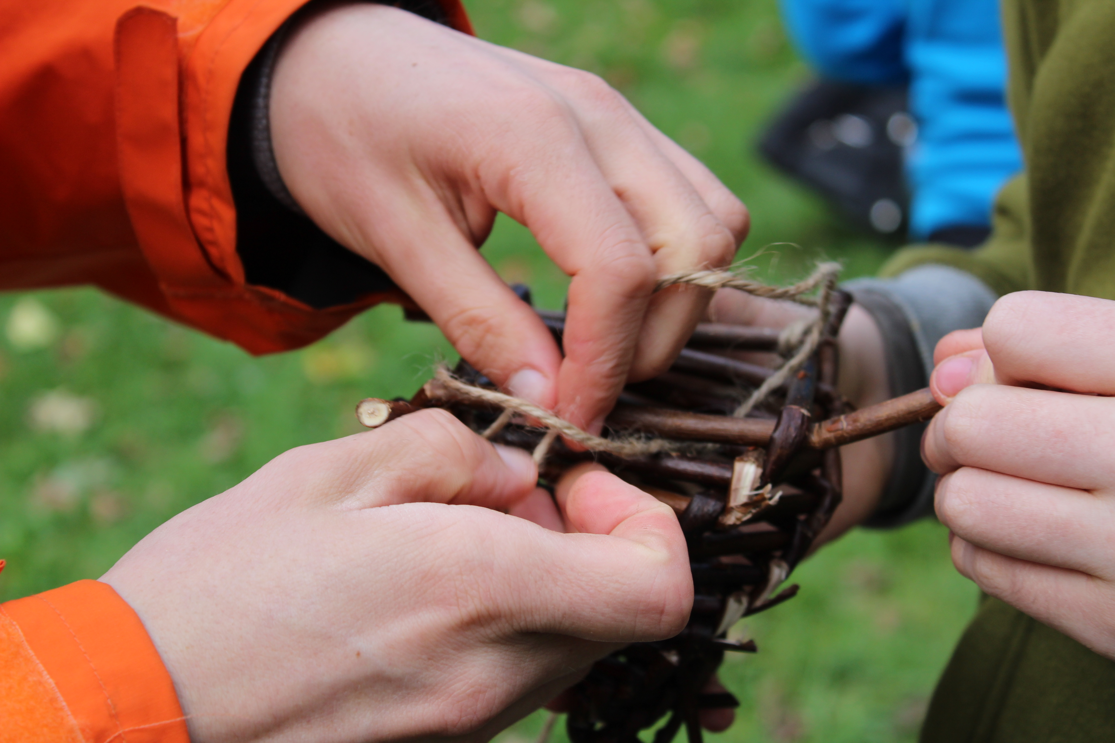
    - 3-7 August 2020
  Young People’s Online Programme
  Who? Those aged 11-17, with a connection to Quakers.
  WHAT? An opportunity to gather online to build community and connection, to explore personal faith and current issues and develop spirituality.
  WHERE? Online, held on Zoom
  WHEN? Monday 3-Friday 7 August, a daily two hour zoom session and an evening epilogue.
  HOW MUCH? Free. Bursaries for data costs may be available from your Local or Area Meeting.
  Book by 17 July 2020!
  “I'm excited by this opportunity to keep doing Quaker stuff, especially seeing friends we only see at BYM. I enjoyed being able to talk to everyone, it’s very good fun and I highly recommend it!” –a participant of he weekly online Quaker youth group.
  
  a CHANCE TO build community
  games, discussion and worship
  friendship, support, connection
  Explore Personal, Faith and Current Issues
  To book: https://forms.quaker.org.uk/2020-cyp-yp-op/
  or contact us at judea@quaker.org.uk
  020 7663 1160
  Bookings will be confirmed on receipt and final details will be sent after closing date.

